
Name: ______________________________________ Date: ________________________
Student Exploration: Golf Range
BACKGROUND: Projectile motion is another example of two-dimensional motion in a plane! In this case, the two dimensions are vertical (up and down) and horizontal (forward and back). In this simulation, you will investigate key aspects of projectile motion.

You are a member of the LASS Golf Team and are competing in the ROPSSAA Golf Championships. If your golf ball travels the farthest distance, the LASS team wins!! The question is, at what angle should you launch the golf ball to achieve the maximum distance for the given launch speed?

You will be investigating the following questions:
1) For a given launch speed, what launch angle will produce the maximum horizontal range?
2) How does maximum height achieved vary with launch angle for a given launch speed?
3) Can different launch angles achieve the same target distance for a given launch speed?

YOU MAY WORK IN PARTNERS AS YOU DISCUSS RESULTS, BUT EACH PARTNER MUST WRITE UP THE ANALYSIS QUESTIONS IN HIS OR HER OWN WORDS!!

Part A: Hypothesis
- Make a prediction regarding what launch angle will produce the maximum horizontal range for a projectile launched from level ground and landing back on level ground. Provide a sketch or written reason to support your hypothesis.

Joining a Gizmo Class: Open Chrome and Google Explore Learning Gizmo to start the program. Select Login/Enroll and under the Student Class Enrollment type in the class code LH8K2X93JW. Create your username and password. Click on the “Golf Range” Gizmo in the class list to start the simulation.

Activity B:  Velocity Vectors | Click Reset each time you need to adjust a parameter  Select Atmosphere: None  Set v_{initial} to 70.0 m/s and θ to 35.0 degrees.  Select: Show Paths Show Grid Show crosshairs Show Velocity Vectors

B Introductory Activity: Examining Velocity Vectors
2.Run the simulation several times with the velocity vectors on using several different launch angles. Start with a small angle (e.g. 35 °).We will set the horizontal direction as x and the vertical direction as y.

- Discuss how the Vx and V_{y} vectors vary during the projectile travel for a given launch angle and speed. How do these results match with our understanding of the conditions of projectile motion?

- Increase the launch angle to 65° but keep the launch speed the same. How do the initial magnitudes of the Vx and Vx vectors compare to their values at a lower launch angle? Explain your observation.

- Click Advanced Features and set the launch height (h_{person}) of the person to 150m. Set the angle to be 0°
and repeat the experiment. How do the V_{x} and V_{y} vectors vary now?

Activity C:  Variation of Projectile Path with Launch Angle | Click Reset and check that Atmosphere: None is selected.  Set v_{initial} to 70.0 m/s and θ to 10.0 degrees.  Reset hperson to 0.0 m  Select: Show Paths Show Grid Show Crosshairs  Deselect: Show Velocity Vectors

- Run the simulation a number of times to investigate how the trajectory varies with launch angle.
Record your observations in the table below. The time of flight is given to the nearest +/- 0.01 s.
You need to read the maximum Height and Maximum Horizontal Distance from the projectile path
recorded on the grid. Turn on “Show Crosshairs” to help you do this.
Assume your uncertainty in these values is +/- 5 m.

Variation of Launch Range and Height with Angle for Launch Speed: 70.0 m/s
Launch Angle (°) | Maximum Horizontal Distance (m) | Maximum Height (m) | Total Time in Air (s)
10.0
15.0
20.0
25.0
30.0
35.0
40.0
45.0
50.0
55.0
60.0
65.0
70.0
75.0
80.0
- a) Complete the smaller chart below with the same headings to compare complementary launch angles.

Launch Angle (°) | Maximum Horizontal Distance (m) | Maximum Height (m) | Total Time in Air (s)
15.0
75.0
30.0
60.0

b) In the space below, produce accurate sketches for the 30.0° and the 60.0° launches on the same axes.
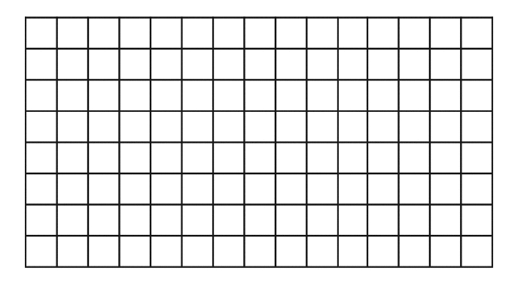

- a) Add air resistance to your simulation by selecting Atmosphere:Air. Run the simulaton again for launch angles of 30.0  and 60.0 .
Launch Angle (°) | Maximum Horizontal Distance (m) | Maximum Height (m) | Total Time in Air (s)
30.0
60.0

b) How has air resistance impacted the projectile path?

- The Moon has much less gravity than Earth and has an extremely thin atmosphere.
a)Predict how the projectile would be affected under the Moon’s gravitational field.

- Select g= 1.6 m/s² and select Atmosphere: None to simulate the moon and retry the 30.0 and 60.0 launch angles. What do you observe now?

Discussion: Refer to specific examples from your data charts to support your discussion
- a) What trend did you observe for the horizontal range as the launch angle varied from 10° to 80°?

- What trend did you observe in the time of flight (or “hang time”)?

- i) What did you observe about the projectiles launched at the same speed but complementary angles (e.g. 30° and 60°)? (We will later relate this result to the “gunner’s equations” for a projectile.)

- How would this information be useful if you needed to hit a particular target with a projectile over hilly landscape.

- What launch angle provides the maximum horizontal range for a projectile launched at a given speed? Discuss how this result compared with your prediction.

Rubric:
Category | Level 4 | Level 3 | Level 2 | Level 1
Completion &  Analysis  Inquiry: Level  __________ | All questions are complete  Analysis is consistent with results  Discussion consistently refers to specific data values to support the analysis | All questions are complete  Analysis is consistent with results  Some supporting examples are provided. | Most questions are complete  Analysis is sometimes consistent with results | Few questions are complete  Analysis is missing or not consistent with results
Communication:  Level:  _________ | Discussion is clearly written with excellent spelling and grammar  Excellent attention to units and significant digits  Supporting examples provided. | Discussion is clearly written with good spelling and grammar  Good attention to units and significant digits  Some supporting examples provided. | Discussion is clearly written.  Several supporting examples are provided | Clarity of discussion and grammar/spelling could be improved.  Few supporting examples are provided.
Comments:

